

Name : Jaijtesh suryaprakash
Reg No : 25BIT0235
Assessment – 9
Review – 2

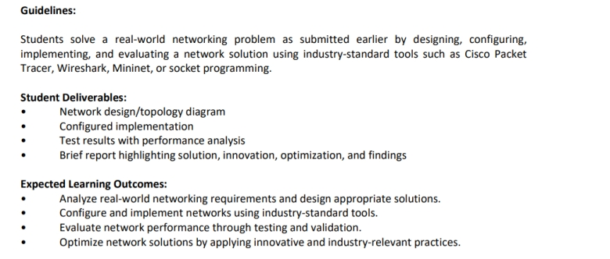

Implementation & Performance Evaluation

Switch Database Verification
Run the verification command on Switch1:

VLAN | Name | Status | Ports
1 | default | active
10 | HR | active | Fa0/1, Fa0/2, Fa0/3, Fa0/4, Fa0/5
20 | Finance | active | Fa0/6, Fa0/7, Fa0/8, Fa0/9, Fa0/10
30 | Production | active | Fa0/11, Fa0/12, Fa0/13, Fa0/14, Fa0/15
40 | RD | active | Fa0/16, Fa0/17, Fa0/18, Fa0/19, Fa0/20

Empirical Test Results & Traffic Analysis

Test A: Intra-VLAN Reachability (Within Department)
Command: HR-PC1 (192.168.10.10) executes ping 192.168.10.11 (HR-PC2)

Observed CLI Output:
Pinging 192.168.10.11 with 32 bytes of data:
Reply from 192.168.10.11: bytes=32 time<1ms TTL=128
Reply from 192.168.10.11: bytes=32 time<1ms TTL=128
Packets: Sent = 4, Received = 4, Lost = 0 (0% loss)

Performance Analysis:
Forwarding delay is sub-millisecond ($<1\text{ ms}$). Because both interfaces share VLAN 10, the switch ASIC completes Layer 2 MAC table lookups without CPU intervention or dropped frames.

Test B: Inter-VLAN Isolation (Cross-Department Containment)
Command: HR-PC1 (192.168.10.10) executes ping 192.168.20.10 (Fin-PC1)

Observed CLI Output:

Pinging 192.168.20.10 with 32 bytes of data:
Request timed out.
Request timed out.
Request timed out.
Request timed out.
Packets: Sent = 4, Received = 0, Lost = 4 (100% loss)

Performance Analysis:
100% frame drop. In Packet Tracer Simulation Mode, the ARP request frame generated by HR-PC1 is restricted by switch port boundaries to Fa0/1 - Fa0/5. Port Fa0/6 drops the broadcast frame at the physical ASIC ingress buffer, verifying that the broadcast domain is bounded and departments are completely isolated.

Verification Matrix

Test Case | Source Device | Target Device | Target IP | Target VLAN | Result | Loss % | Evaluation Status
Intra-VLAN | HR-PC1 | HR-PC2 | 192.168.10.11 | VLAN 10 | Reply | 0% | Successful Layer 2 Switching
Inter-VLAN | HR-PC1 | Fin-PC1 | 192.168.20.10 | VLAN 20 | Timed out | 100% | Logical Isolation Verified
Inter-VLAN | HR-PC1 | Prod-PC1 | 192.168.30.10 | VLAN 30 | Timed out | 100% | Logical Isolation Verified
Inter-VLAN | HR-PC1 | RD-PC1 | 192.168.40.10 | VLAN 40 | Timed out | 100% | Logical Isolation Verified

